Rotational Rearrangement

Definition
# Source: AI Source: Provided by: [Data Path: Persons Table -> ID Column: 1, Name_En Column: Motasem Essam] -> From: [ChatGPT] on [7/25/2026]
Rotational Rearrangement is a type of geometric figure rearrangement in which a figure or one of its parts is turned around a fixed point through a specified angle to place it in a new position, usually to form a desired arrangement.
During a pure rotation, the figure's shape, size, and orientation relative to the rotation itself are preserved in the sense that every point turns through the same angle. Its position and orientation in the plane change.

Simple Definition
# Source: AI Source: Provided by: [Data Path: Persons Table -> ID Column: 1, Name_En Column: Motasem Essam] -> From: [ChatGPT] on [7/25/2026]
Rotational rearrangement means turning a geometric figure or piece around a fixed point to fit it into a new arrangement.
Example
A triangular piece is rotated by ${90}^{∘}$ to fit beside another piece and help form a larger geometric figure.

Main Classification of Rotational Rearrangement
# Source: AI Source: Provided by: [Data Path: Persons Table -> ID Column: 1, Name_En Column: Motasem Essam] -> From: [ChatGPT] on [7/25/2026]
The following is a practical classification based on how the rotation is performed or used. These categories can overlap and are not a universally standardized taxonomy.

1. Quarter-Turn Rearrangement
# Source: AI Source: Provided by: [Data Path: Persons Table -> ID Column: 1, Name_En Column: Motasem Essam] -> From: [ChatGPT] on [7/25/2026]
A figure or piece is rotated through ${90}^{∘}$, which is one-quarter of a full turn. This is useful when a piece must change from a horizontal orientation to a vertical one, or vice versa.
Example: A triangular piece is turned ${90}^{∘}$ counterclockwise so that one of its sides fits against another piece.
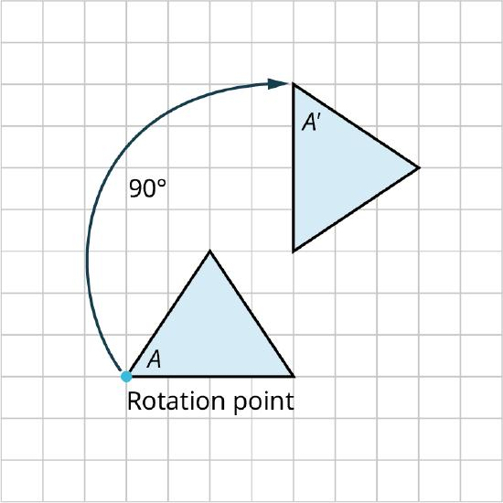

2. Half-Turn Rearrangement
# Source: AI Source: Provided by: [Data Path: Persons Table -> ID Column: 1, Name_En Column: Motasem Essam] -> From: [ChatGPT] on [7/25/2026]
A figure or piece is rotated through ${180}^{∘}$, which is half a full turn. The figure faces the opposite direction while retaining its shape and size.
Example: A triangular piece pointing upward is turned ${180}^{∘}$ so that its tip points downward and fits into a gap.
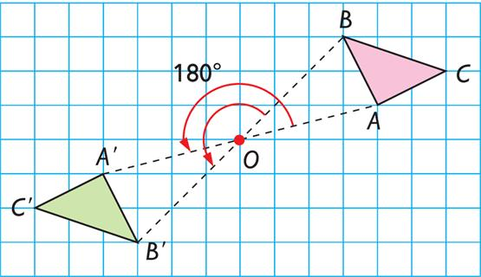

3. Three-Quarter-Turn Rearrangement
# Source: AI Source: Provided by: [Data Path: Persons Table -> ID Column: 1, Name_En Column: Motasem Essam] -> From: [ChatGPT] on [7/25/2026]
A figure or piece is rotated through ${270}^{∘}$ in a specified direction. This is equivalent to a ${90}^{∘}$ rotation in the opposite direction.
Example: A rectangular piece is turned ${270}^{∘}$ counterclockwise to fit into a vertical space in a geometric puzzle.
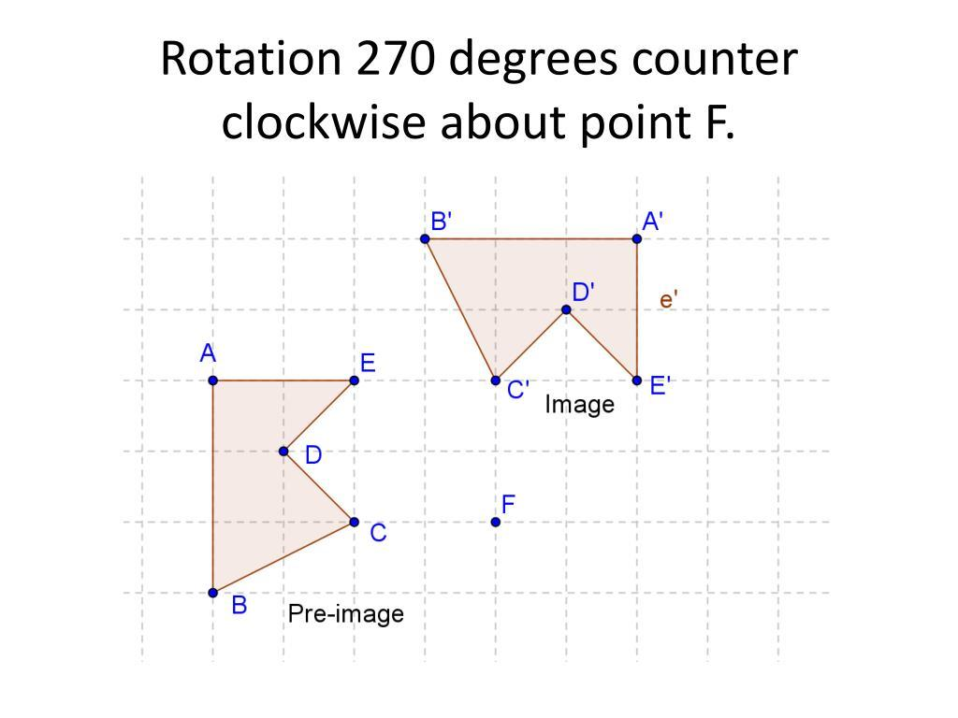

4. Small-Angle Rotational Rearrangement
# Source: AI Source: Provided by: [Data Path: Persons Table -> ID Column: 1, Name_En Column: Motasem Essam] -> From: [ChatGPT] on [7/25/2026]
A figure or piece is rotated through an angle smaller than ${90}^{∘}$. This is useful when pieces must fit along slanted edges or form angled patterns.
Example: A triangular piece is rotated ${45}^{∘}$ to align one of its edges with a diagonal boundary.
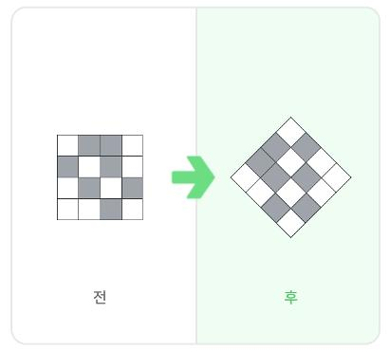

5. Whole-Figure Rotational Rearrangement
# Source: AI Source: Provided by: [Data Path: Persons Table -> ID Column: 1, Name_En Column: Motasem Essam] -> From: [ChatGPT] on [7/25/2026]
The entire geometric figure is rotated as one object around a fixed center. Every point of the figure turns through the same angle.
Example: A complete L-shaped arrangement is rotated ${90}^{∘}$ to fit into a different orientation of a target outline.
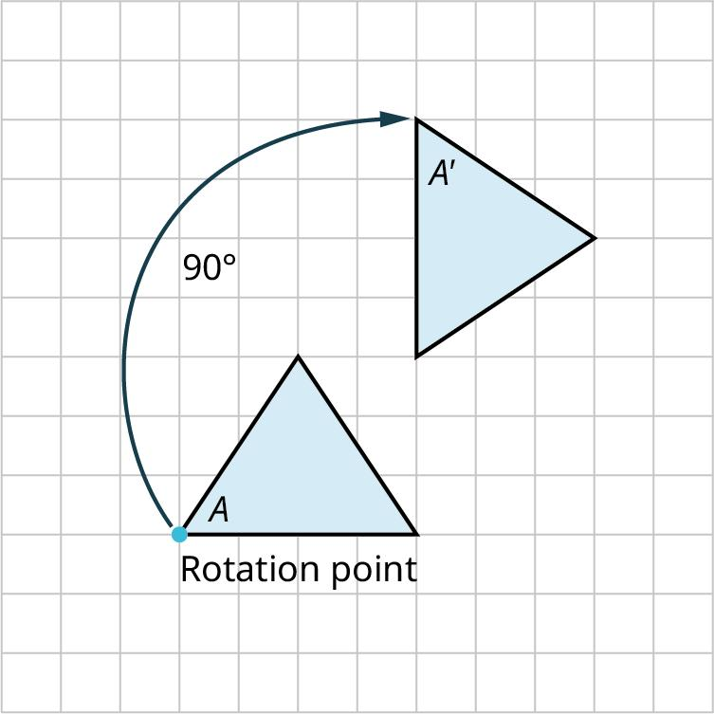

6. Individual-Piece Rotational Rearrangement
# Source: AI Source: Provided by: [Data Path: Persons Table -> ID Column: 1, Name_En Column: Motasem Essam] -> From: [ChatGPT] on [7/25/2026]
Only one piece, or a selected subset of pieces, is rotated while the other pieces remain fixed.
Example: In a tangram puzzle, one triangular piece is rotated to fill an empty triangular region without moving the other pieces.
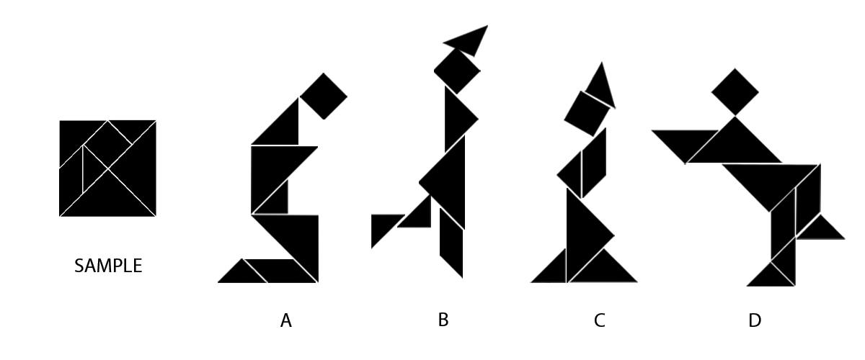

7. Center-Based Rotational Rearrangement
# Source: AI Source: Provided by: [Data Path: Persons Table -> ID Column: 1, Name_En Column: Motasem Essam] -> From: [ChatGPT] on [7/25/2026]
A piece is rotated around a specified center or pivot point. The chosen center determines the circular path followed by each point of the piece.
Example: A square is rotated ${90}^{∘}$ around one of its vertices so that it occupies a new position while that vertex remains fixed.
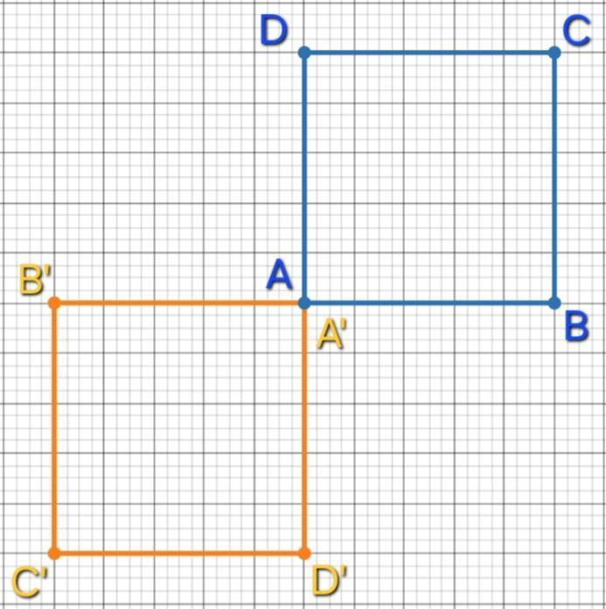

8. Sequential Rotational Rearrangement
# Source: AI Source: Provided by: [Data Path: Persons Table -> ID Column: 1, Name_En Column: Motasem Essam] -> From: [ChatGPT] on [7/25/2026]
Several pieces are rotated one after another to produce a final arrangement. Each rotation may prepare the figure for the next step.
Example: Three triangular pieces are rotated in sequence to form a larger triangular or polygonal pattern.
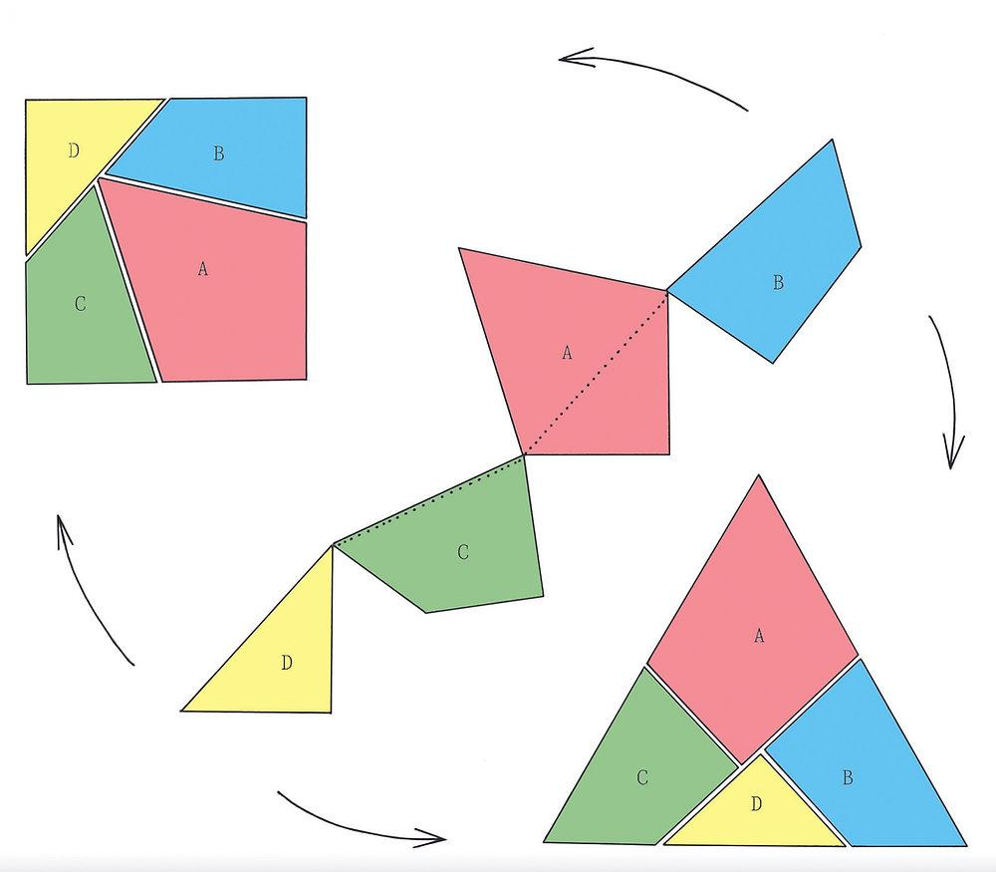

Mathematical Representation of Rotational Rearrangement
# Source: AI Source: Provided by: [Data Path: Persons Table -> ID Column: 1, Name_En Column: Motasem Essam] -> From: [ChatGPT] on [7/25/2026]
A rotation is defined by three main elements:
- Center of rotation: The fixed point around which the figure turns.
- Angle of rotation: The amount of turning.
- Direction of rotation: Clockwise or counterclockwise.
The standard notation is:
$$R_{O,θ}\left(P\right)=P'$$
where $O$ is the center, $θ$ is the angle, $P$ is the original point, and $P'$ is its rotated position.
Coordinate formula
For a rotation about the origin $O=\left(0,0\right)$:
Counterclockwise rotation
$$\begin{aligned}{90}^{∘}&:\left(x,y\right)→\left(-y,x\right) \\ {180}^{∘}&:\left(x,y\right)→\left(-x,-y\right) \\ {270}^{∘}&:\left(x,y\right)→\left(y,-x\right)\end{aligned}$$
For an arbitrary angle $θ$:
$$\begin{aligned}x'&=x\cos{θ}-y\sin{θ} \\ y'&=x\sin{θ}+y\cos{θ}\end{aligned}$$
For a center $O=\left(h,k\right)$, first subtract the center coordinates, rotate, and then add the center coordinates back.

Detailed Mathematical Example
# Source: AI Source: Provided by: [Data Path: Persons Table -> ID Column: 1, Name_En Column: Motasem Essam] -> From: [ChatGPT] on [7/25/2026]
Suppose a triangular piece has vertices
$$A=\left(1,1\right), B=\left(4,1\right), C=\left(1,3\right)$$
Rotate it ${90}^{∘}$ counterclockwise about the origin.
Using the rule
$$\left(x,y\right)→\left(-y,x\right)$$
the new vertices are:
$$\begin{aligned}A'&=\left(-1,1\right) \\ B'&=\left(-1,4\right) \\ C'&=\left(-3,1\right)\end{aligned}$$
The rotated triangle has the same side lengths and area as the original triangle. Its position and orientation have changed, allowing it to fit a different part of a geometric arrangement.

Properties of Rotational Rearrangement
# Source: AI Source: Provided by: [Data Path: Persons Table -> ID Column: 1, Name_En Column: Motasem Essam] -> From: [ChatGPT] on [7/25/2026]
- Shape preservation: The original and rotated figures are congruent.
- Length preservation: Every segment retains its length.
- Angle preservation: Every angle retains its measure.
- Area preservation: The area of a planar figure remains unchanged.
- Fixed center: The center of rotation does not move.
- Equal rotation angle: Every point turns through the same angle in the same direction.
- Distance preservation: The distance of every point from the center remains constant.
- Position change: The figure generally occupies a different position, unless the rotation leaves it unchanged.

Rotational Rearrangement vs. Other Rearrangement Types
# Source: AI Source: Provided by: [Data Path: Persons Table -> ID Column: 1, Name_En Column: Motasem Essam] -> From: [ChatGPT] on [7/25/2026]
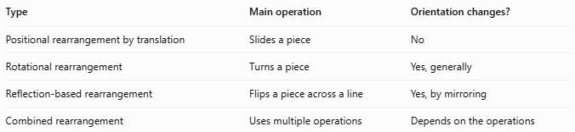
Type | Main operation | Orientation changes?
Positional rearrangement by translation | Slides a piece | No
Rotational rearrangement | Turns a piece | Yes, generally
Reflection-based rearrangement | Flips a piece across a line | Yes, by mirroring
Combined rearrangement | Uses multiple operations | Depends on the operations
Important distinction: Rotation is not the same as reflection. A rotation turns a piece without producing a mirror image. Some puzzles require both rotation and reflection to fit all pieces.

Classification Summary
# Source: AI Source: Provided by: [Data Path: Persons Table -> ID Column: 1, Name_En Column: Motasem Essam] -> From: [ChatGPT] on [7/25/2026]
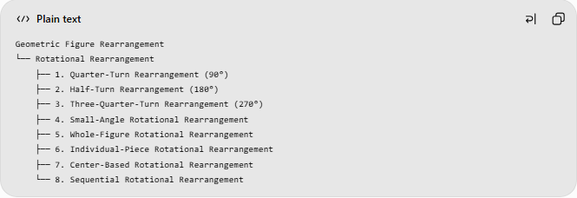
Geometric Figure Rearrangement
└── Rotational Rearrangement
├── 1. Quarter-Turn Rearrangement (90°)
├── 2. Half-Turn Rearrangement (180°)
├── 3. Three-Quarter-Turn Rearrangement (270°)
├── 4. Small-Angle Rotational Rearrangement
├── 5. Whole-Figure Rotational Rearrangement
├── 6. Individual-Piece Rotational Rearrangement
├── 7. Center-Based Rotational Rearrangement
└── 8. Sequential Rotational Rearrangement
These are practical descriptive categories, not mutually exclusive mathematical classes. For example, an individual piece can undergo a quarter-turn around a fixed center as part of a sequential rearrangement.

Key Points
# Source: AI Source: Provided by: [Data Path: Persons Table -> ID Column: 1, Name_En Column: Motasem Essam] -> From: [ChatGPT] on [7/25/2026]
- Rotational rearrangement changes the orientation of a piece by turning it around a center.
- A rotation preserves shape, size, lengths, angles, and area.
- Common rotation angles include ${45}^{∘}$, ${90}^{∘}$, ${180}^{∘}$, and ${270}^{∘}$.
- The center of rotation and the direction of rotation determine the new position.
- Rotational rearrangement is commonly used in tangram puzzles, geometric dissection, tiling, and spatial reasoning.

Conclusion
# Source: AI Source: Provided by: [Data Path: Persons Table -> ID Column: 1, Name_En Column: Motasem Essam] -> From: [ChatGPT] on [7/25/2026]
Rotational Rearrangement is a geometric rearrangement method in which a figure or one of its parts is turned around a fixed point to achieve a new arrangement. It is especially useful when pieces must change orientation to fit together, while their shapes and dimensions remain unchanged.

